**Lab 2 assignment**

Name: Yerraballi Suresh Kumar Reddy

USN:19MCAR0080

MCA

Python Programming Lab

Date: 05/02/2021

**1. Write python programs to perform fallowing tasks:**

**a. Find 2 nd largest number among five numbers using if-else**

**Code:**

list1 = [10, 20, 4, 45, 99]

mx=max(list1[0],list1[1])

secondmax=min(list1[0],list1[1])

n =len(list1)

for i in range(2,n):

if list1[i]>mx:

secondmax=mx

mx=list1[i]

elif list1[i]>secondmax and \

mx != list1[i]:

secondmax=list1[i]

print("Second highest number is : ",\

str(secondmax))

**Output:**

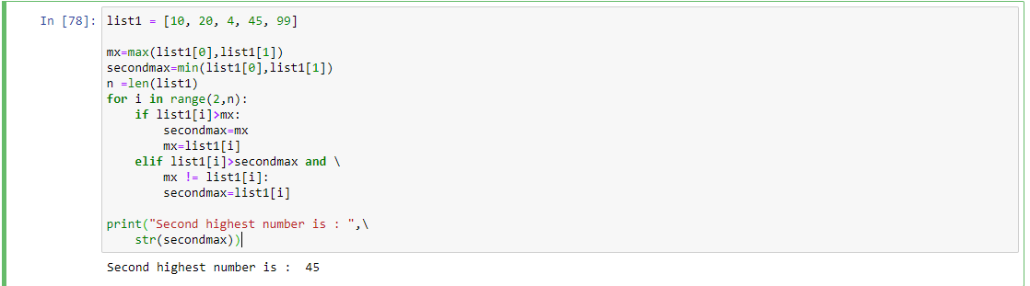

**b. Find 2 nd smallest number among five numbers**

**Code:**

lst = []

num = int(input('How many numbers: '))

for n in range(num):

numbers = int(input('Enter number '))

lst.append(numbers)

print("\nMinimum element in the list is :", min(lst))

**Output:**

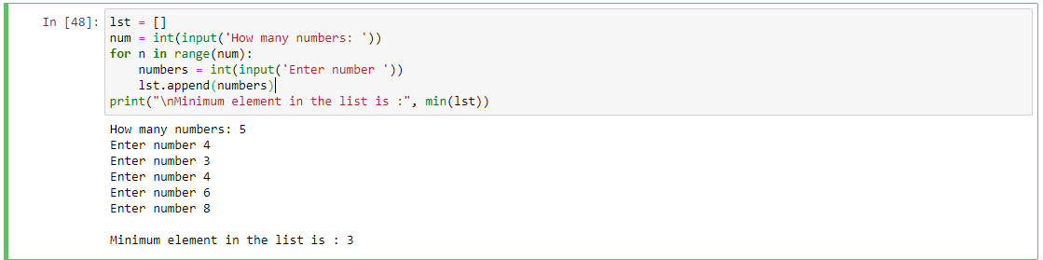

**2. Write python programs to perform fallowing tasks:**

**a. Find given number is prime or not**

num=int(input("Enter number: "))

if num > 1:

for i in range(2, num):

if (num % i) == 0:

print(num, "is not a prime number")

break

else:

print(num, "is a prime number")

else:

print(num, "is not a prime number")

**Output:**

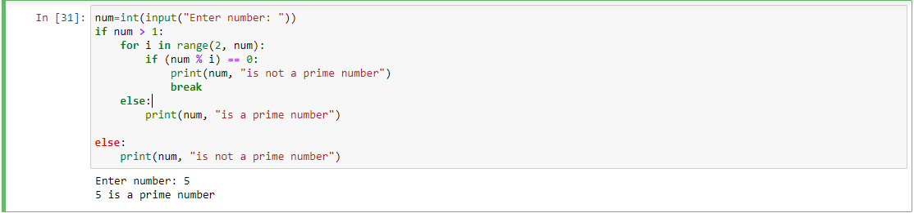

**b. Print alternate even number from 1 to n**

**Code:**

num = int(input(" Please Enter any Maximum Number : "))

for number in range(1, num + 1):

if(number % 4 == 0):

print("{0}".format(number))

